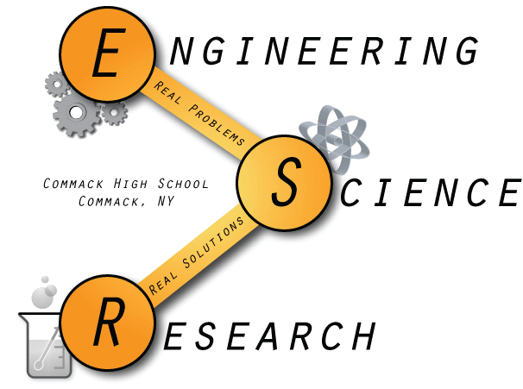
Commack High School
Research Class of 2016

Rahul Chakravorty
Georgia Institute of Technology
The Incorporation of Mobius Characteristics in Bridges

“In high school, I looked forward to two things – research and the end of it”.

Xiaoxuan (Emily) Chen
University of Pennsylvania
Smart Windows for Modulating Space Heating

“Research gave me the opportunity to take on the title: ‘#Chen@Penn2020’.”

Daniel Choi
Boston College
The Effect of Ginger (Zingiber Officinale) on the Neuroinflammation Precipitated by Environmental Copper

Monica Cramer
Binghamton University
Analysis of Multi-center Robotic Inguinal Hernia Outcomes Across New York State

“Knock knock
Who’s there?
Not Monica
She graduated.”

Brianna Delgado
Carnegie Mellon University
Simulating Microbial Communities to Model Network Evolution

“In research, I worked about as hard as autocorrect when Kurtz writes emails.”
Victoria Ferlauto
Emory University
The Response of Planarian to Light during the Regeneration Process

“Victory without honor is hollow.”
Jake Finnell
University of Alabama
Does the Memory of Planaria Transfer after Separation?

Vignesh Gunasekaran
Stony Brook University
Does St. John’s Wort Cause Addiction in Planaria?

“Science is full of infinite possibilities, and all you need to be a great scientist is a thirst for knowledge”

Austin Izen
University of Michigan
The Development of Sports Equipment for the Mentally and Physically Disabled

“I feel like I'm too busy writing history to read it” -Kanye West

Aryana Javaheri
Brown University
The Incorporation of Mobius Characteristics in Bridges

“Research may be tedious, but it's always progressive, whether it's a step in the right direction or an indication to change your path.”

Daniel Jung
William E. Macaulay Honors College
The Correlations Between Systemic Problems, Age and Gender to the Severity of Periodontal Disease

“Science Research has taught me to never stop questioning in any circumstance. Furthermore, I was taught to never be discouraged, because every failed attempt discarded is another step closer to what I want to accomplish.”

Mikayla Katz
Stony Brook University
Differences in Comorbid Disorders Between Males and Females with Tourette’s Syndrome And Persistent Tic Disorders
“What did you find?” “Oh... Nothing”
Ibrahim Khan
Stony Brook University
Explore the Effect of Resonance Frequencies and the Resulting Vibrational Patterns Produced on Flat Planes

“Closing the research room already‽ It's only 5:00 PM!”

Ryan Lee
New York University
A Comparison of the Visual Reaction Time Between Student Athletes and Non-Athletes

David Li
Harvard University
A Multi-Dimensional Implementation of Named Data Networking for Embedded Systems

“If at first you don't succeed, don't blame Murphy's Law, lest you face the Angry-Murphy's Law next time”.
Noah Marinaro
Cornell University
An Investigation of Past and Current Weather Data from Mohonk Preserve, 1890 to 2012

Lucas Marmorale
University of Michigan
The Structure of the Nuclear Pore Complex in Primary and Metastatic Prostate Cancer Cells

“Research is the greatest way to learn a lot about a little”.

Caitlin Passaro
University of North Carolina at Chapel Hill
Stress, Compassion Satisfaction/Fatigue, and Burnout in Mental Health Professionals

“When you spend months doing research, writing papers, and analyzing data and the only award you win at the science fair awards ceremony is the SAAWA 2016 Volunteer Service Award for past community service work.”

Vincent Pennetti
Boston University
A Genetic Analysis and Organogenesis of Unique Clover Phenotypes

“Plant lives matter.”
Adam Portnoy
Binghamton University
Identifying Weather Trends Over a 100 Year Time Period on the North Shore of Long Island, NY

“There's not a star in heaven that we can't reach” - Troy Bolton and Gabriella Montez
Mehtaab Sawhney
University of Pennsylvania
A Study of Bar and Arc-K Visibility Graphs

“Research is an escape from life.”
Hassam Syed
United States Naval Academy
Social Behavior of Students in a High School Cafeteria and the Importance of Food

“Be proud of who you are, where you are, and what you’ve done to achieve both.”
Erick Vaysman
Binghamton University
The Development of Sports Equipment for the Mentally and Physically Disabled

“I’m not a business man. I’m a business, man.”

